**Shoulders and knee**

**Initial Assessment**

|  |  |  |
| --- | --- | --- |
| **Presenting Symptom/Chief Complaint** | | |
| Pain repeated attack at the both shoulders and both knee (seasonal exacerbation). | | |
| **Main Signs and Symptoms** | | |
| Chronic pain, cold feeling, dull pain in both shoulders and knee joints. Sleep disturbances, difficulty to walk. | | |
| **Other Signs and Symptoms** | | |
| Periodic acute attacks of the pain of the different joints, tiredness. | | |
| **TCM Diagnosis and Treatment (identified TCM disease, TCM differentiation of syndromes)** | | |
| Chronic pain, cold obstruction syndrome. QI stagnation in both shoulders and knee involved from overuse of joint. | | |
| **Treatment Principles and Strategies** | | |
| Remove the cold. Increase blood circulation in the area, expel cold from involved channel. Increase movement of QI. | | |
| **Treatment Plan (Modalities; acupuncture, herbal, dietary, manual therapies), frequency and duration** | | |
| Acupuncture with use of Moxa around the shoulders area (specifically around scapulo-humeral joint). Treatment every third day. | | |
| **Any other Advice Given to Patients** | | |
| weight, level of exercises. Sleep hygiene. SI11, SI 10, SI 13, SI 14, LI 15, TW 14. Tw 15 (bilateral). SI 5 - bilateral -river point any knee pain. ST 41, ST 24 bilateral, with warming needles. GB 34, K 3 - to nourish KI and Liver Yin. Acupuncture - local points. | | |
| **Practitioner:** | **Date:** | **Signature:** |

**Daily Charting____________________________________Patient Name:**

**Date:**

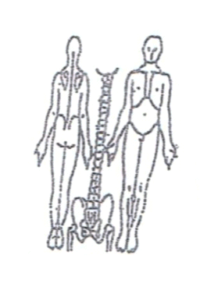**Working Diagnosis:**

Chronic pain, cold obstruction syndrom. QI stagnation in both shoulders and knee area.

S: Dull pain with movement at shoulders and both knee area.

O:

Treatment (P) ↓ weight, ↓ level of exercises. Sleep hygiene. SI11, SI 10, SI 13, SI 14, LI 15, TW 14. Tw 15 (bilateral). SI 5 - bilateral -river point ↓ any knee pain. ST 41, ST 24 bilateral, with warming needles. GB 34, K 3 - to nourish KI and Liver Yin. Acupuncture - local points.

(A) Acupuncture according to the protocol.

**Date:**

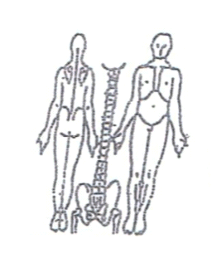**Working Diagnosis:**

S: Pain still aggravated by movement. Tiredness remains, sleep better.

O:

Treatment (P) Acupuncture + Moxa - 1 hour.

(A)

**Date:**

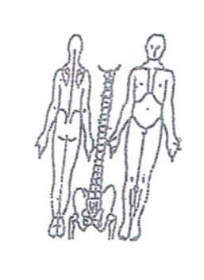**Working Diagnosis:**

S: Pain , still has difficulties with movement, N level of energy. Sleep better.

O:

Treatment (P) Acupuncture - 1 hour, according to the protocol.

(A)

**Date: _______________**

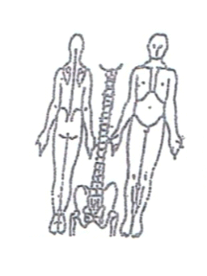**Working Diagnosis:**

S: Pain . Difficulty with movement remains. Sleep and energy N.

O:

Treatment (P) Acupuncture + Moxibustion - 1 hour.

(A)

 **Date:_ _______________**

**Working Diagnosis:**

S: No pain, N ROM in shoulder and knee areas. N daily living function.

O:

Treatment (P) Acupuncture - 1 hour. Stretching exercises 20 minutes.

(A)